JARABE MEXICANO
Marian Liebowitz Artist Management
marian@marianliebowitz.com
619.988.0751

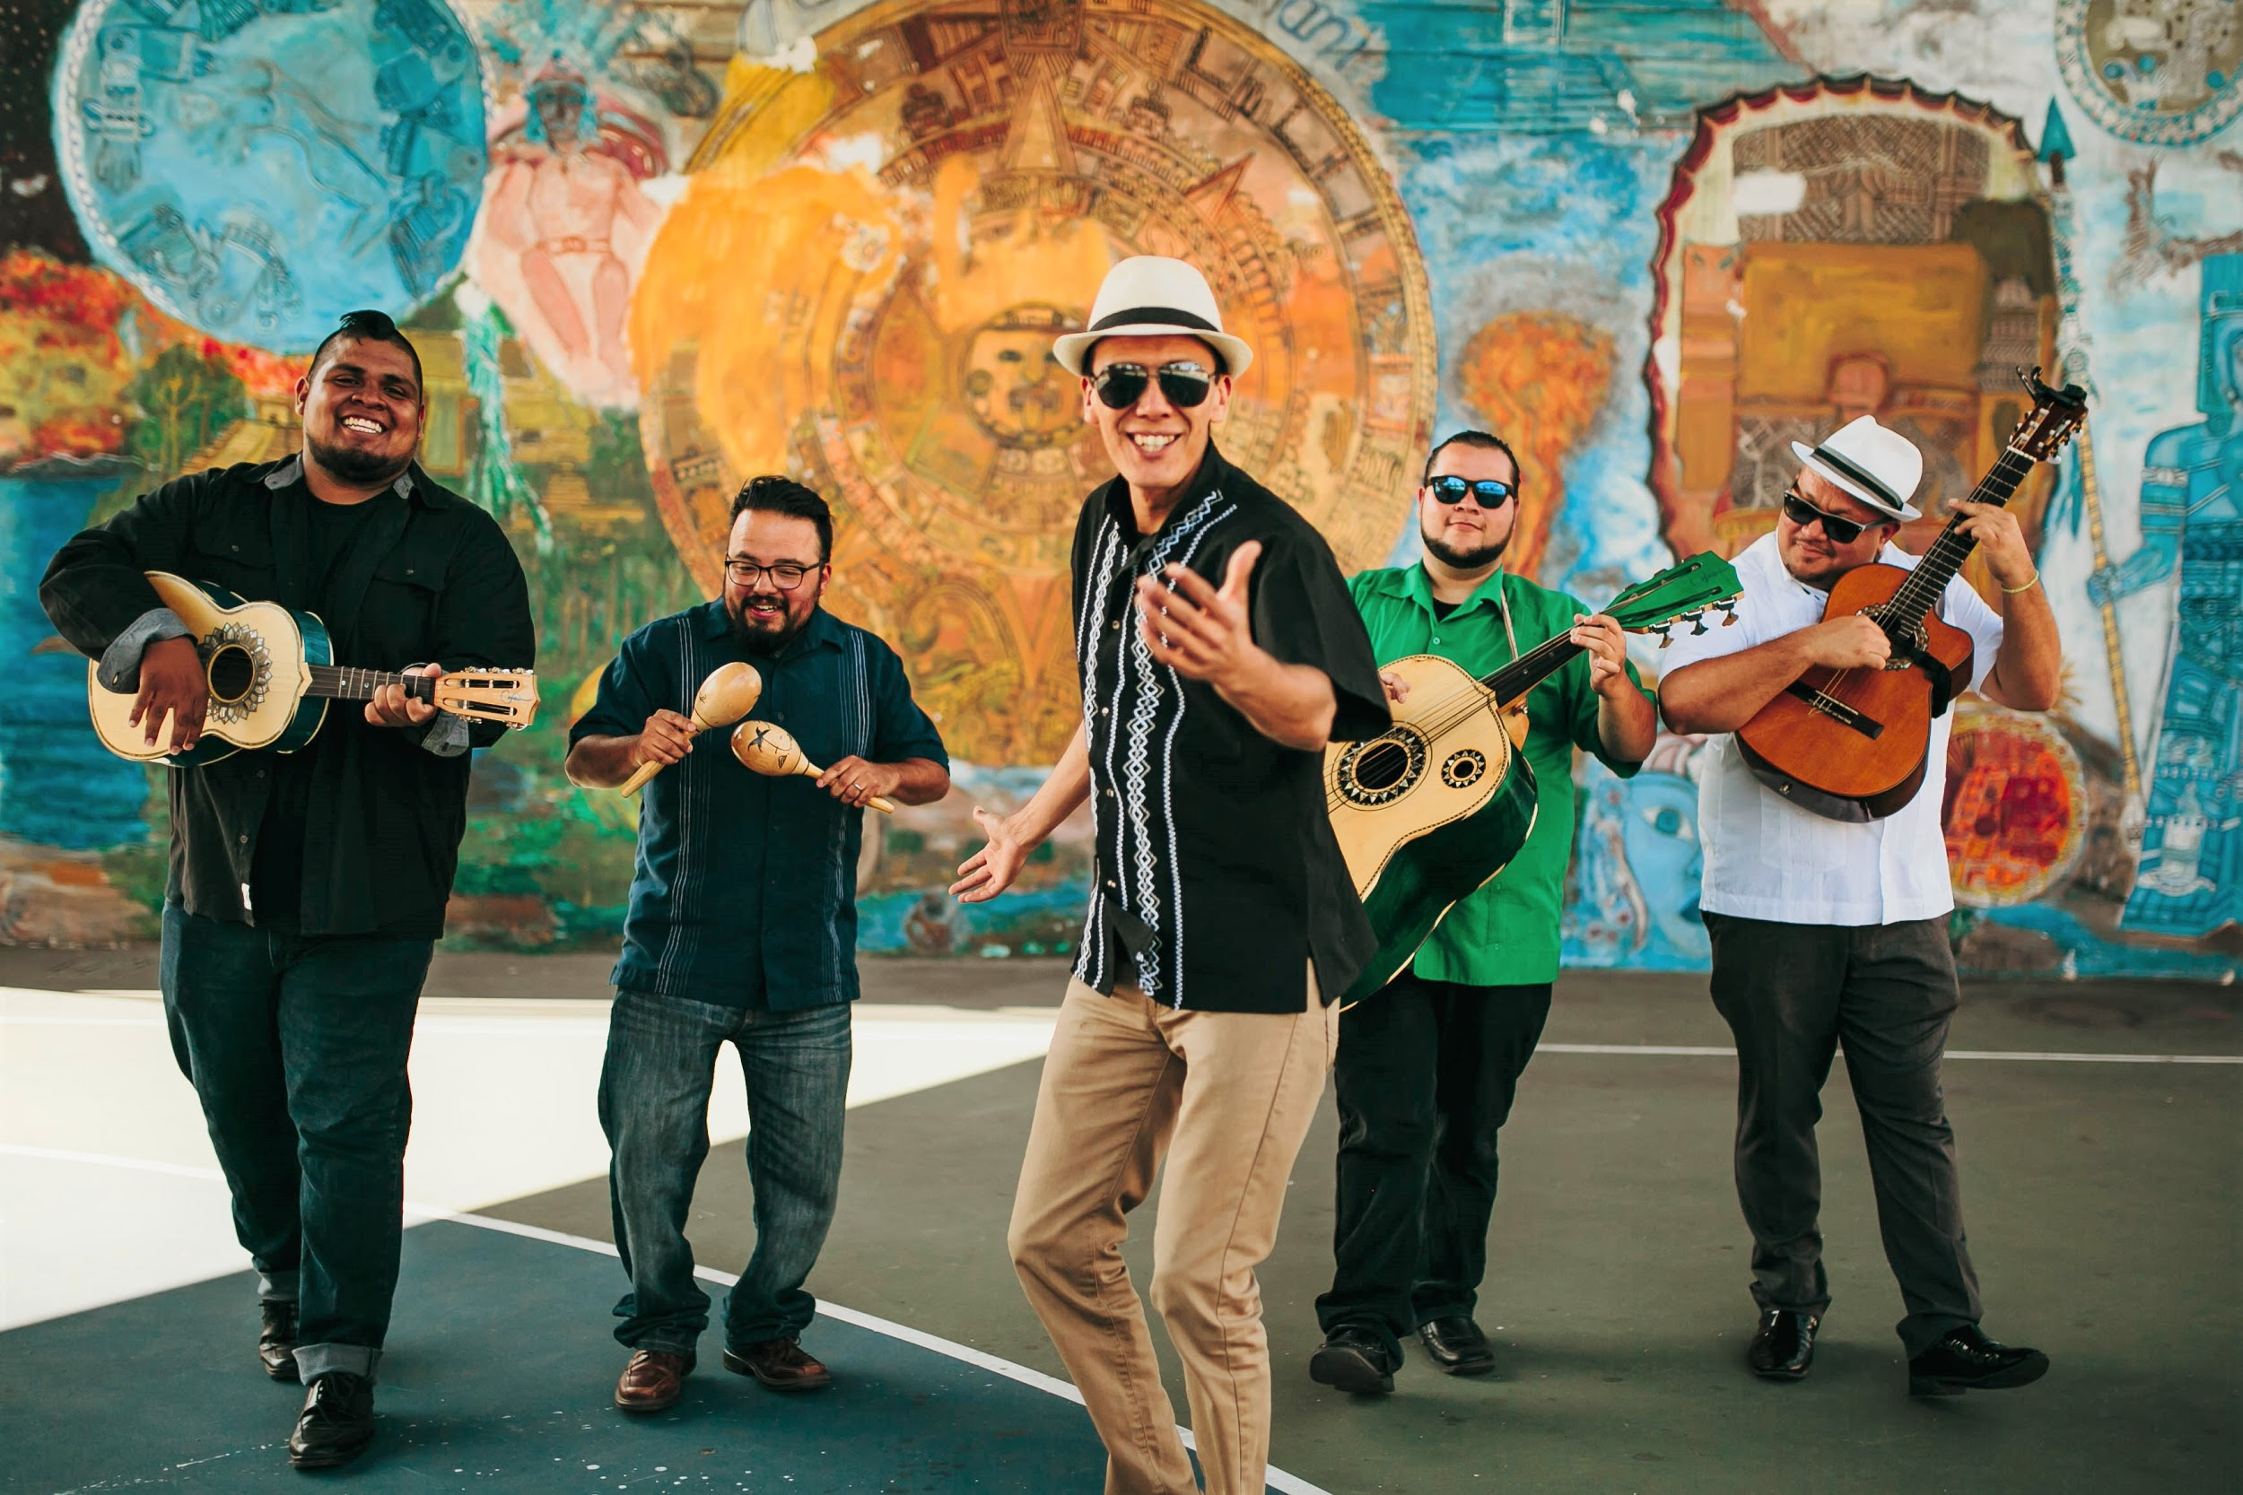
JARABE MEXICANO ON TOUR
Coming soon!

[City, State, Date] — Mexican-American border band Jarabe Mexicano is back on the road with their blended songbook of Mexican Folk music, Rock & Roll, Norteño/Tex-Mex, Latin Rock, and Reggae-Cumbia. Performing on stringed folk instruments accompanied by lively percussion, the band’s down-to-earth charm and harmonized vocals in Spanish and English have gained them acclaim from audiences across the country. Vilar Performing Arts Center raved that "Jarabe Mexicano was thought provoking, heartfelt, and engaging… a season highlight that brought the community together in a way that we’ve never witnessed before."

Lauded as cultural ambassadors by the Mexican Consulate in the United States, Jarabe believes every performance is an opportunity to create a deeper and more inclusive sense of community. Their programming for audiences of all ages features music and personal stories that highlight what it’s like to grow up along the US-Mexico border. From romantic ballads fit for a loving serenade to exuberant dance music that will bring people out of their seats, this border fiesta will be one to remember!

For concert details and tickets information, please visit [Venue Info].

